|  |  |  |  |  |  |
| --- | --- | --- | --- | --- | --- |
| Date | 23-Nov-22 | | | Tester Name | Shahabuddin Syed |
| Environment | Penfax - Test | | | Login used |  |
| Operating System | Windows | Version: | Update: | | |
| Software Used | Edge | Version: | Update: | | |
| Select Software | Version: | Update: | | |
| Release version | 22.4.1 | | | | |
| Title | M11.01 – Project Estimates | | | | |
| Test Type | Regression | | | | |
| Test Scenario | Vested General 10-month member eligible for unreduced pension with different service types has eligibility service > 25 years and age >55<64 | | | | |
|  |  | | | | |
| Expected Results |  | | | | |
| Pass/Fail | Pass | | | JIRA# | N/A |

Describe your steps with screenshots:

Login into Penfax application

Search for the member

Click on their stakeholder ID

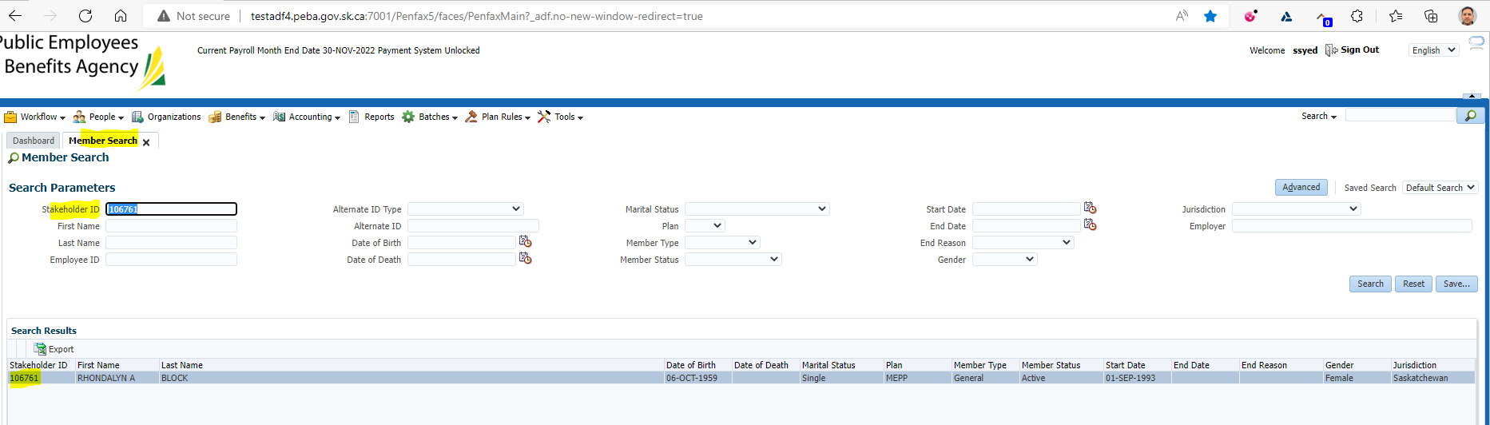

Click on Retirement Projection tab

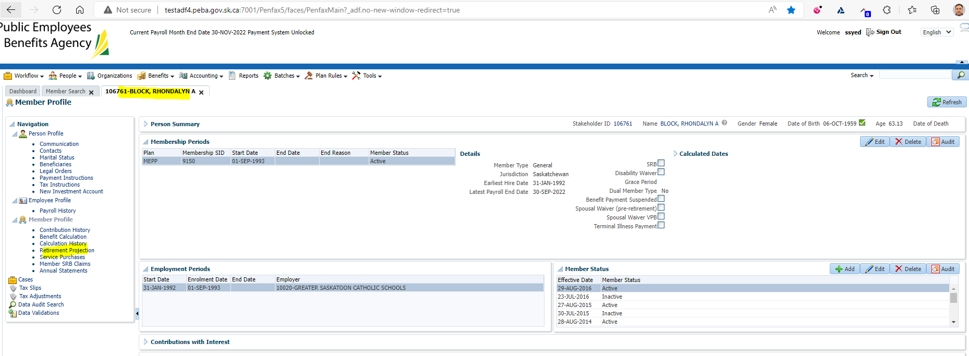

Click on Calculate Retirement Dates

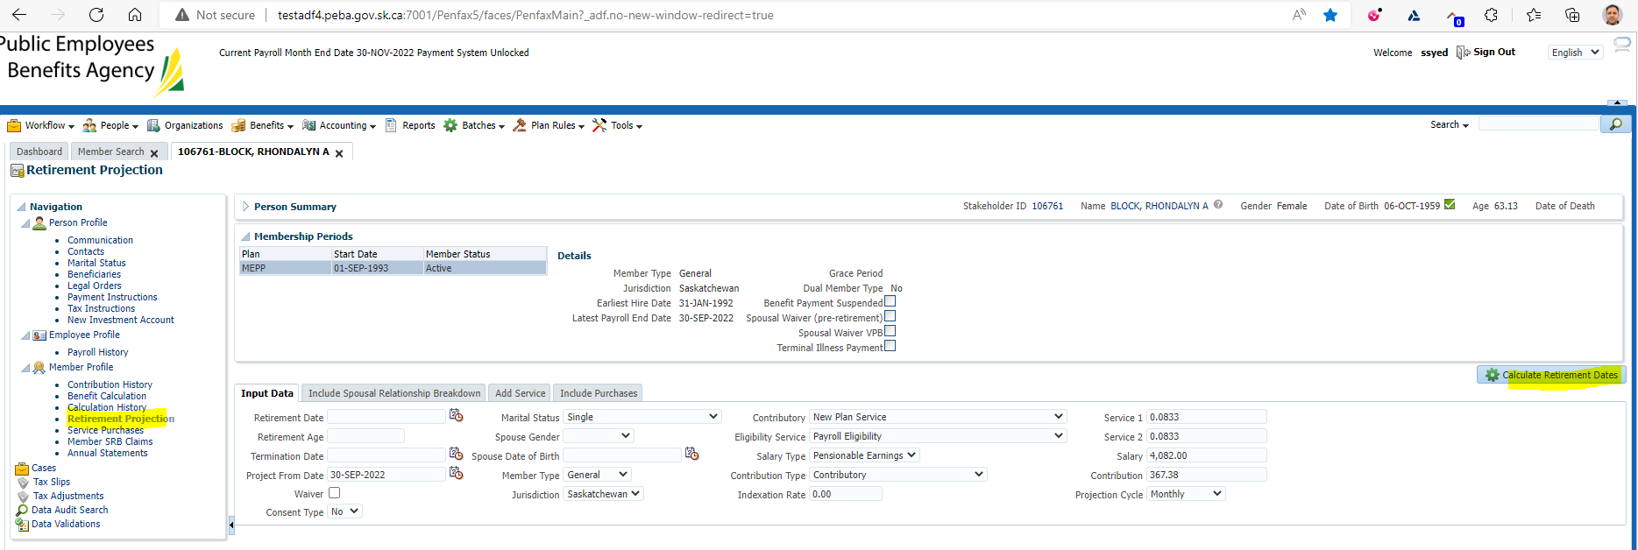

Click on Quote

Make sure it has tick mark on the Quote button under Retirement Dates

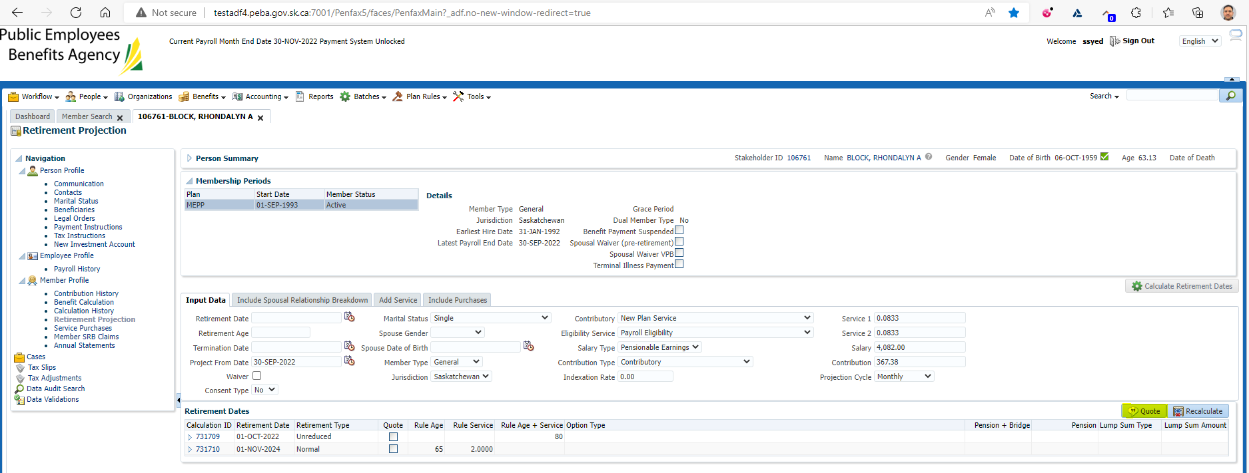

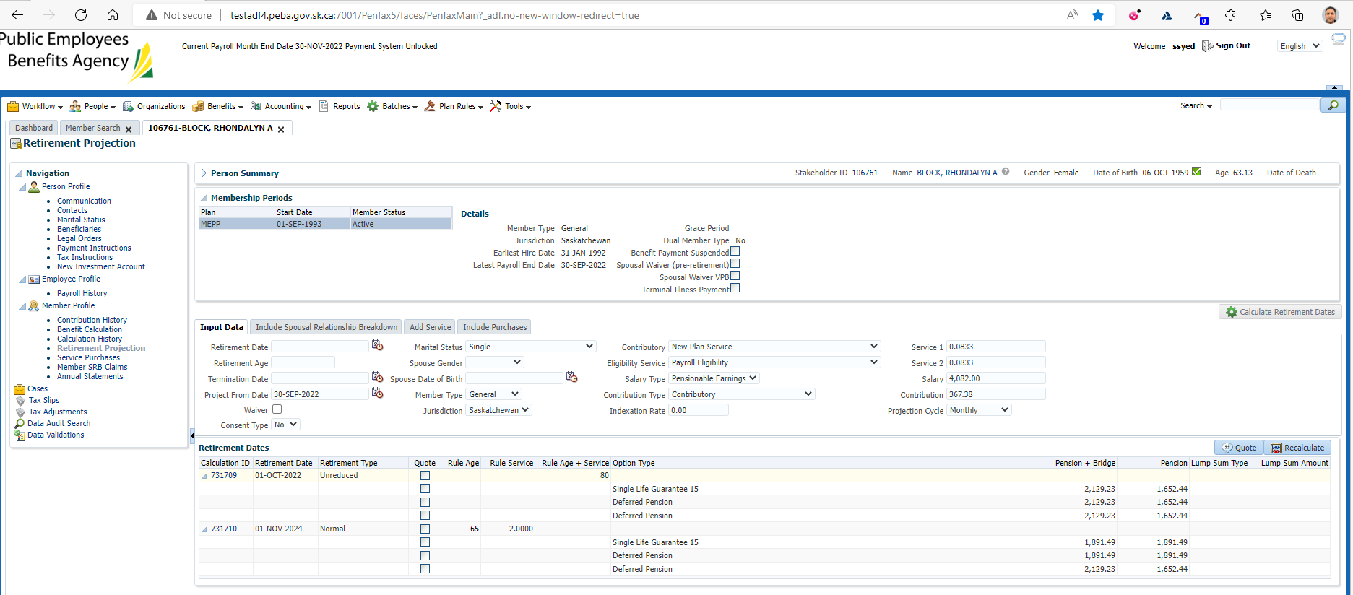

Comparison with Test1 Region

Login into Penfax application

Search for the member

Click on their stakeholder ID

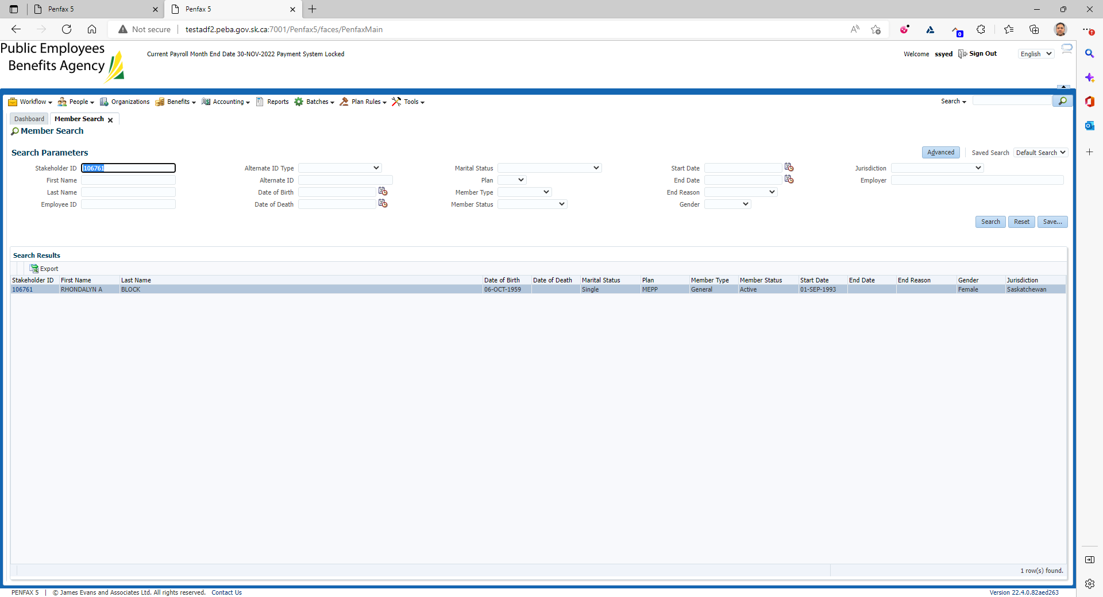

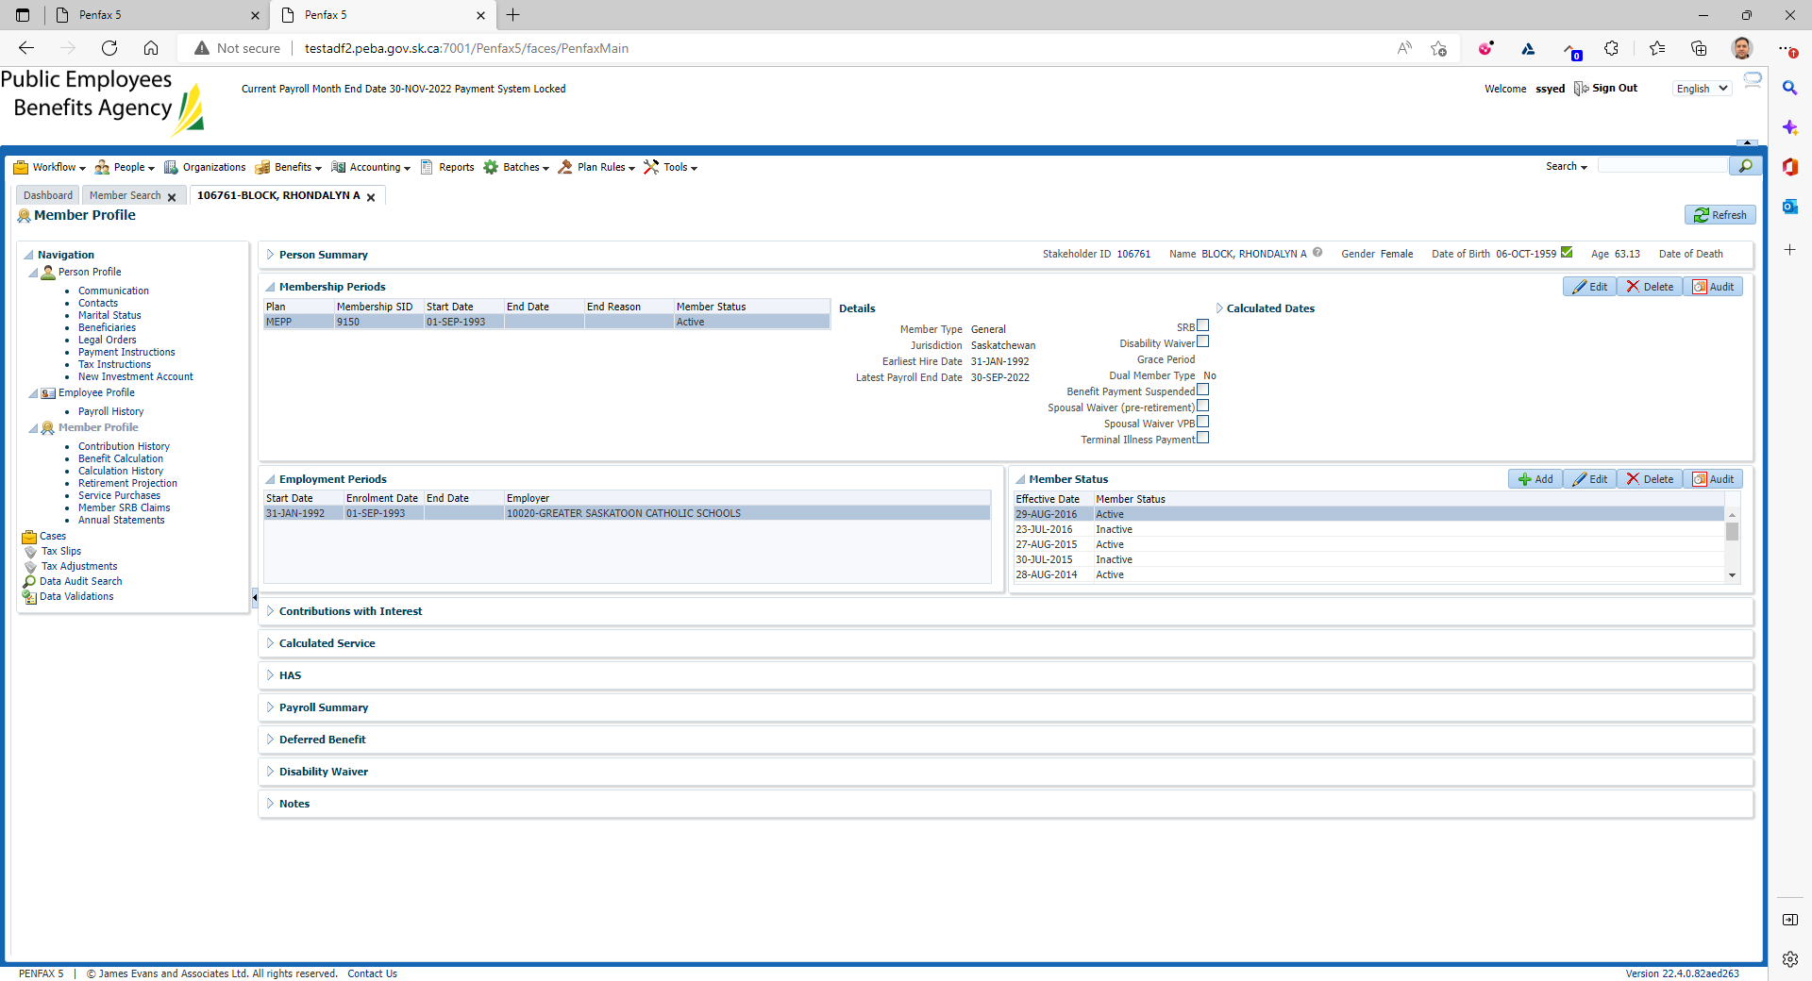

Click on Retirement Projection tab

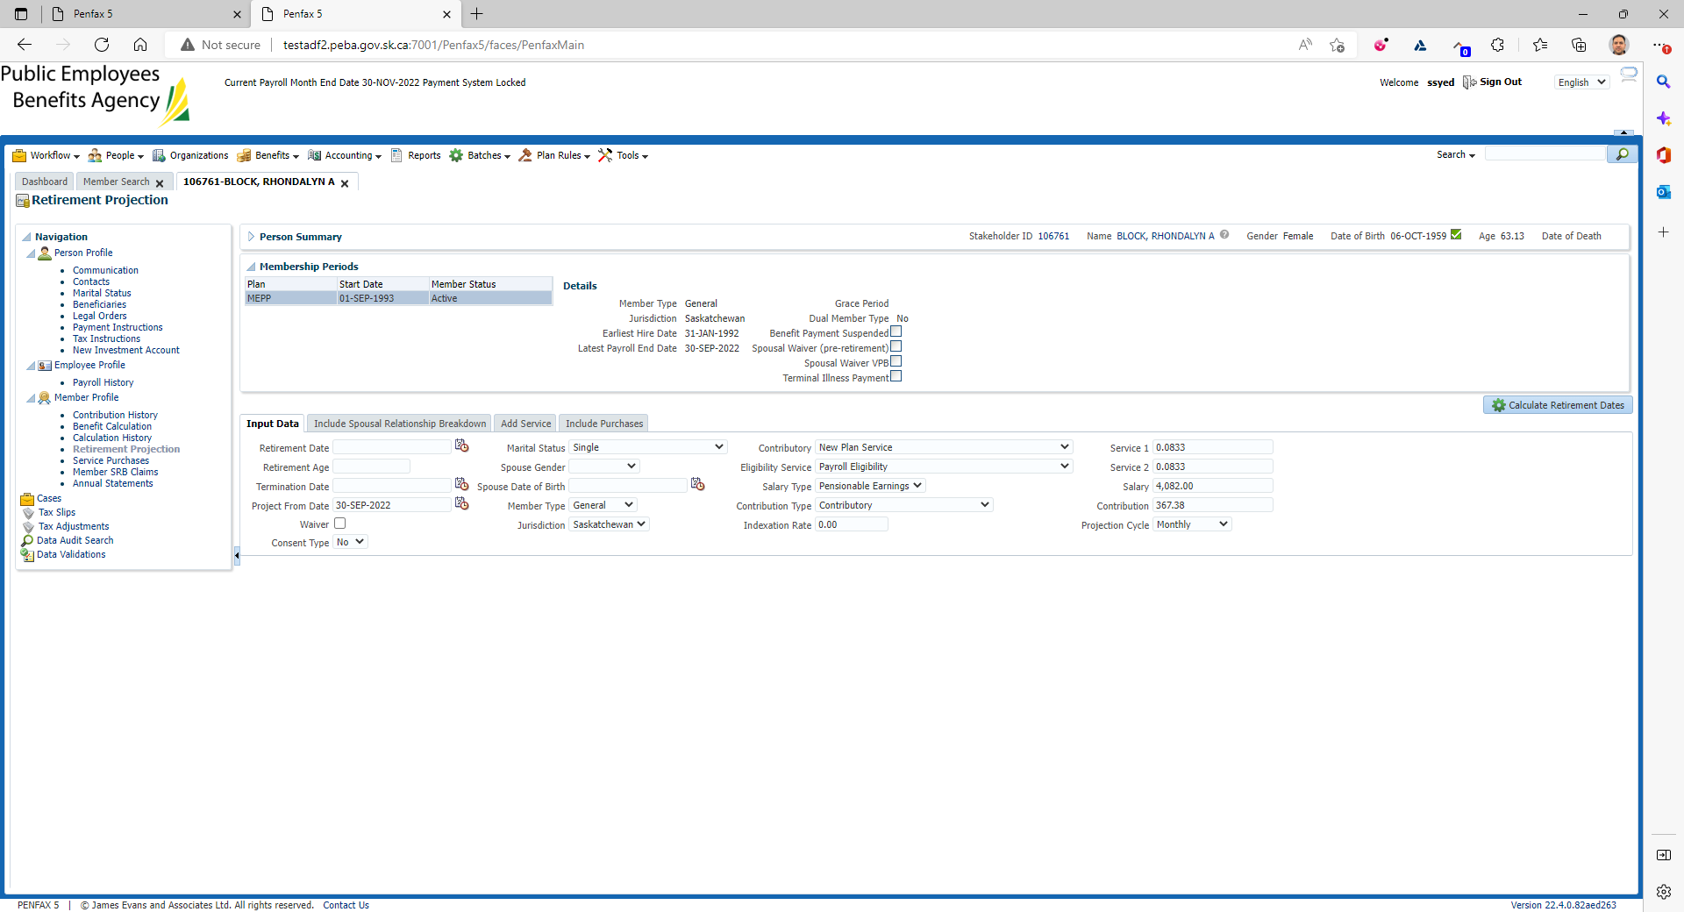

Click on Calculate Retirement Dates

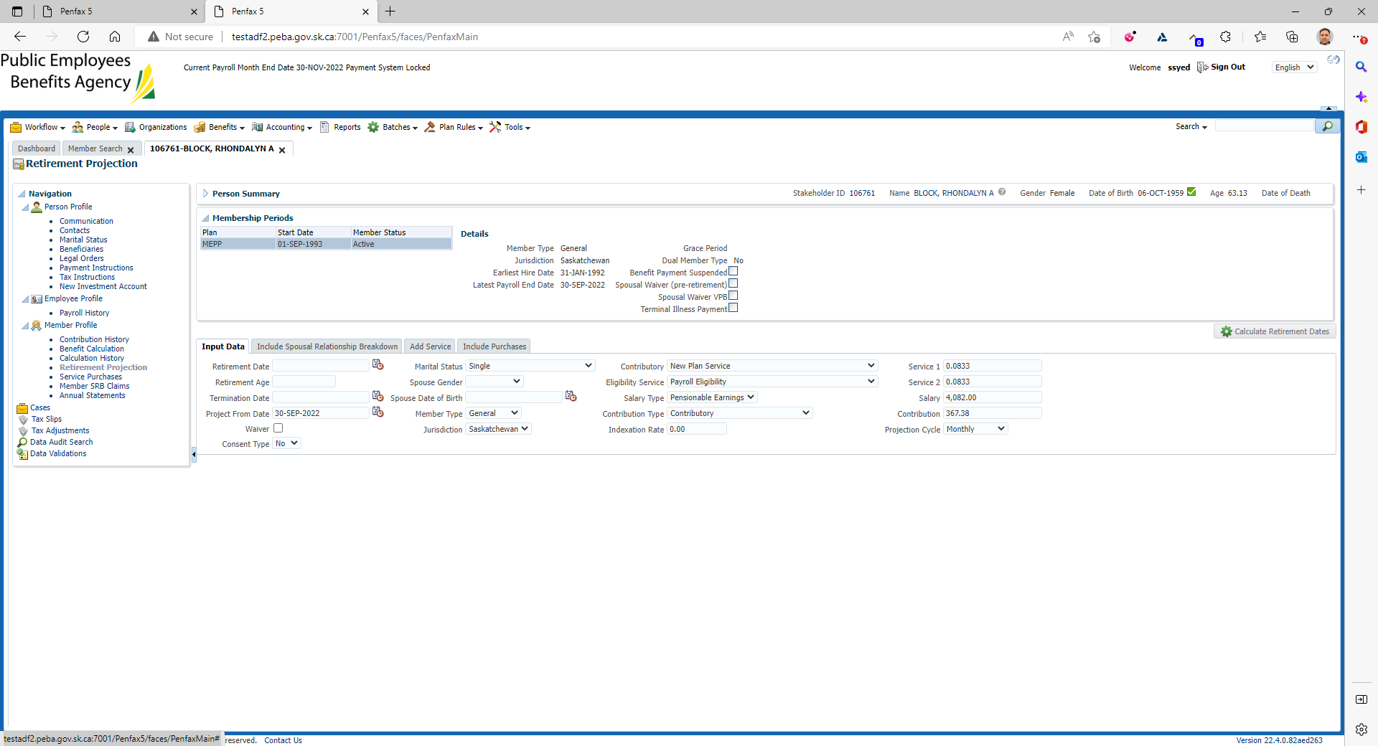

Click on Quote

Make sure it has tick mark on the Quote button under Retirement Dates

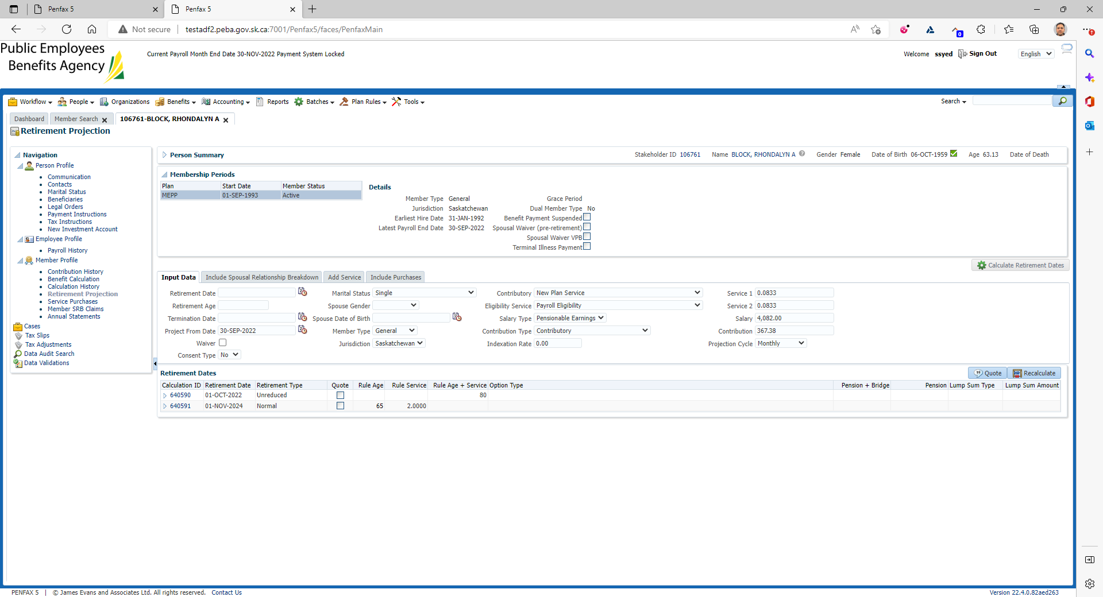

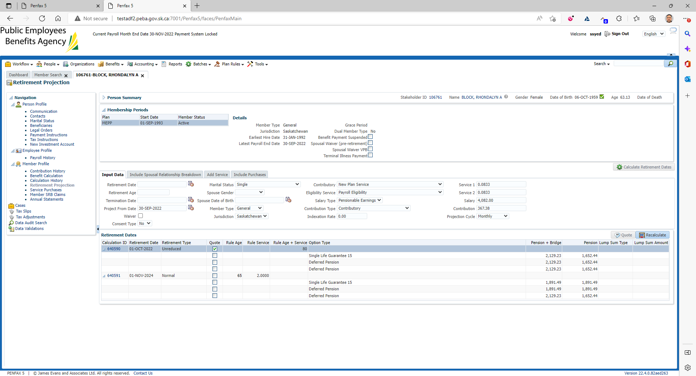

Comparison with Test1 Region

